MP MLA Work
Like this dashboard of MP MLA Work –
- Below CM Monit A, CM Monit A+, and CM Ghoshna Dashboards needs to be created separately
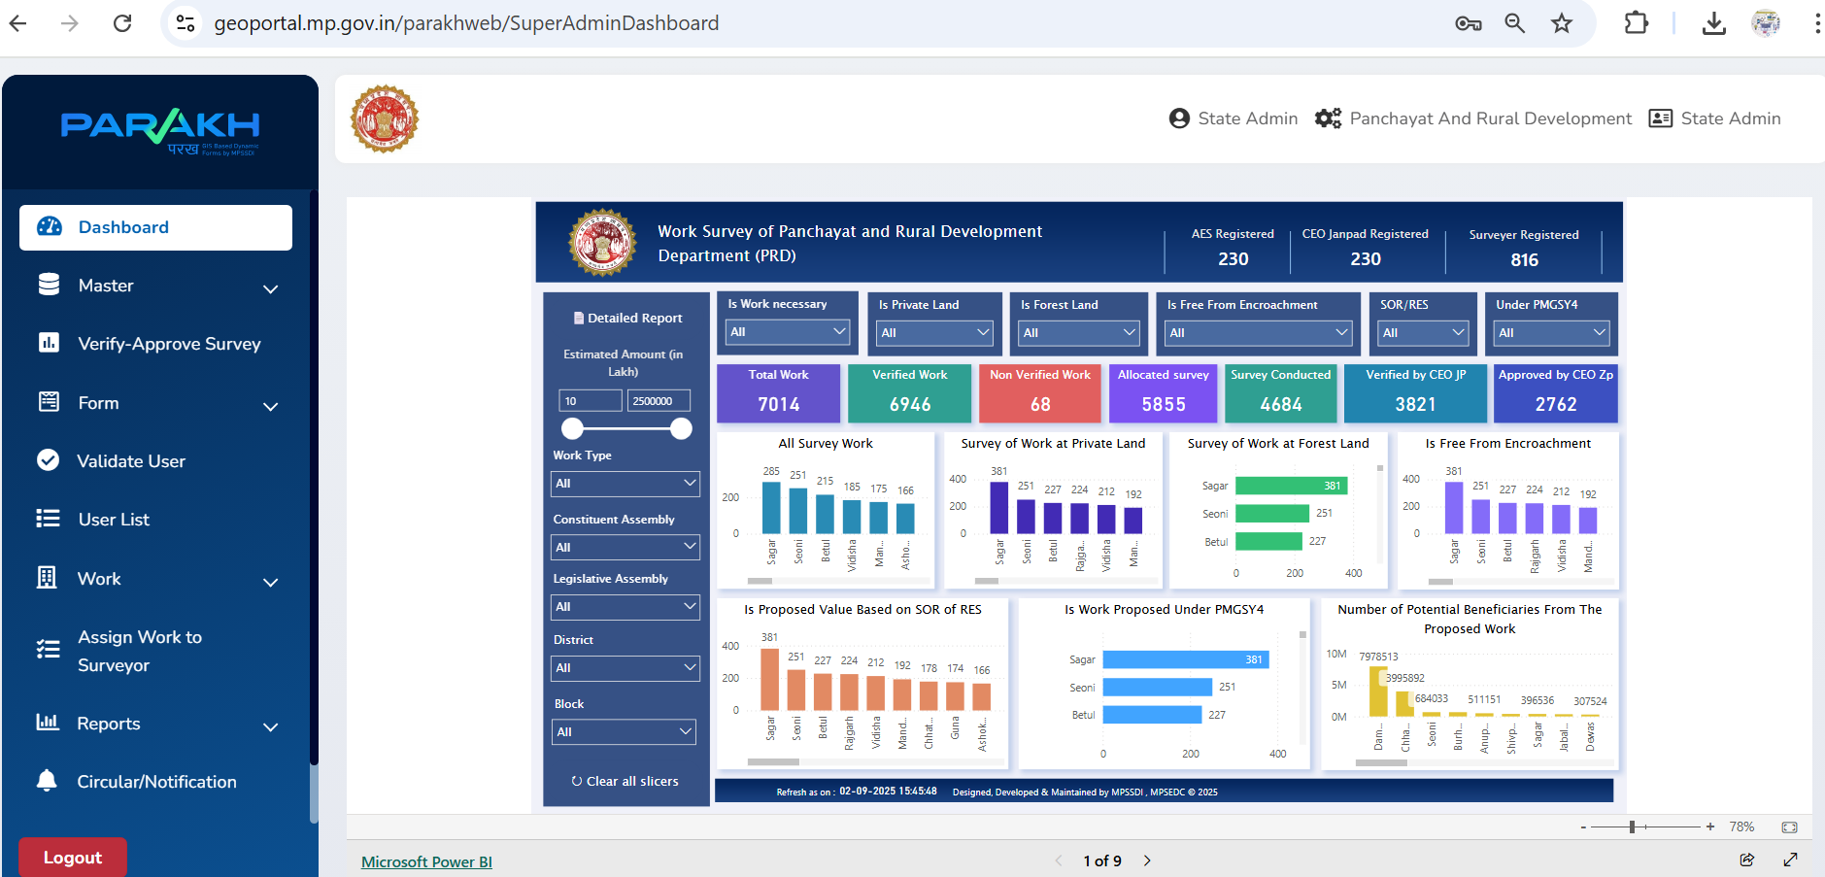
2) For those dashboards - 3 separate summary Reports needs to be created.
with different conditions - Like No of Works >15 lakh, No of works <15, No of duplicate works, no of works surveyed, no of janpad work , no of CEO zila panchayat work, and other columns etc…
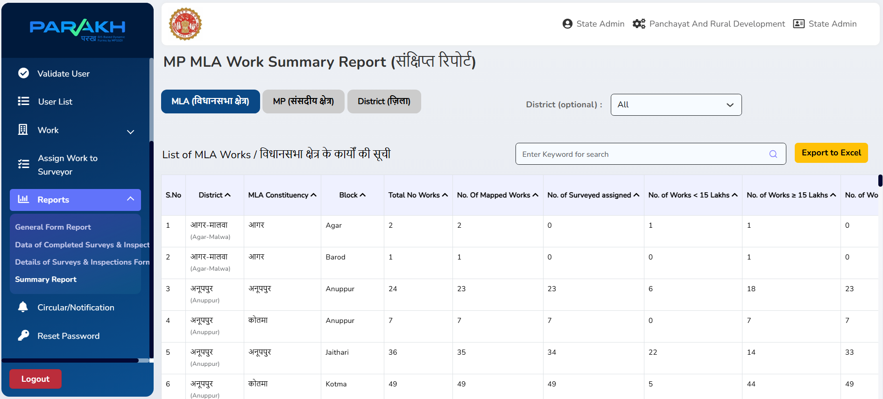

- And District report updation and modification required
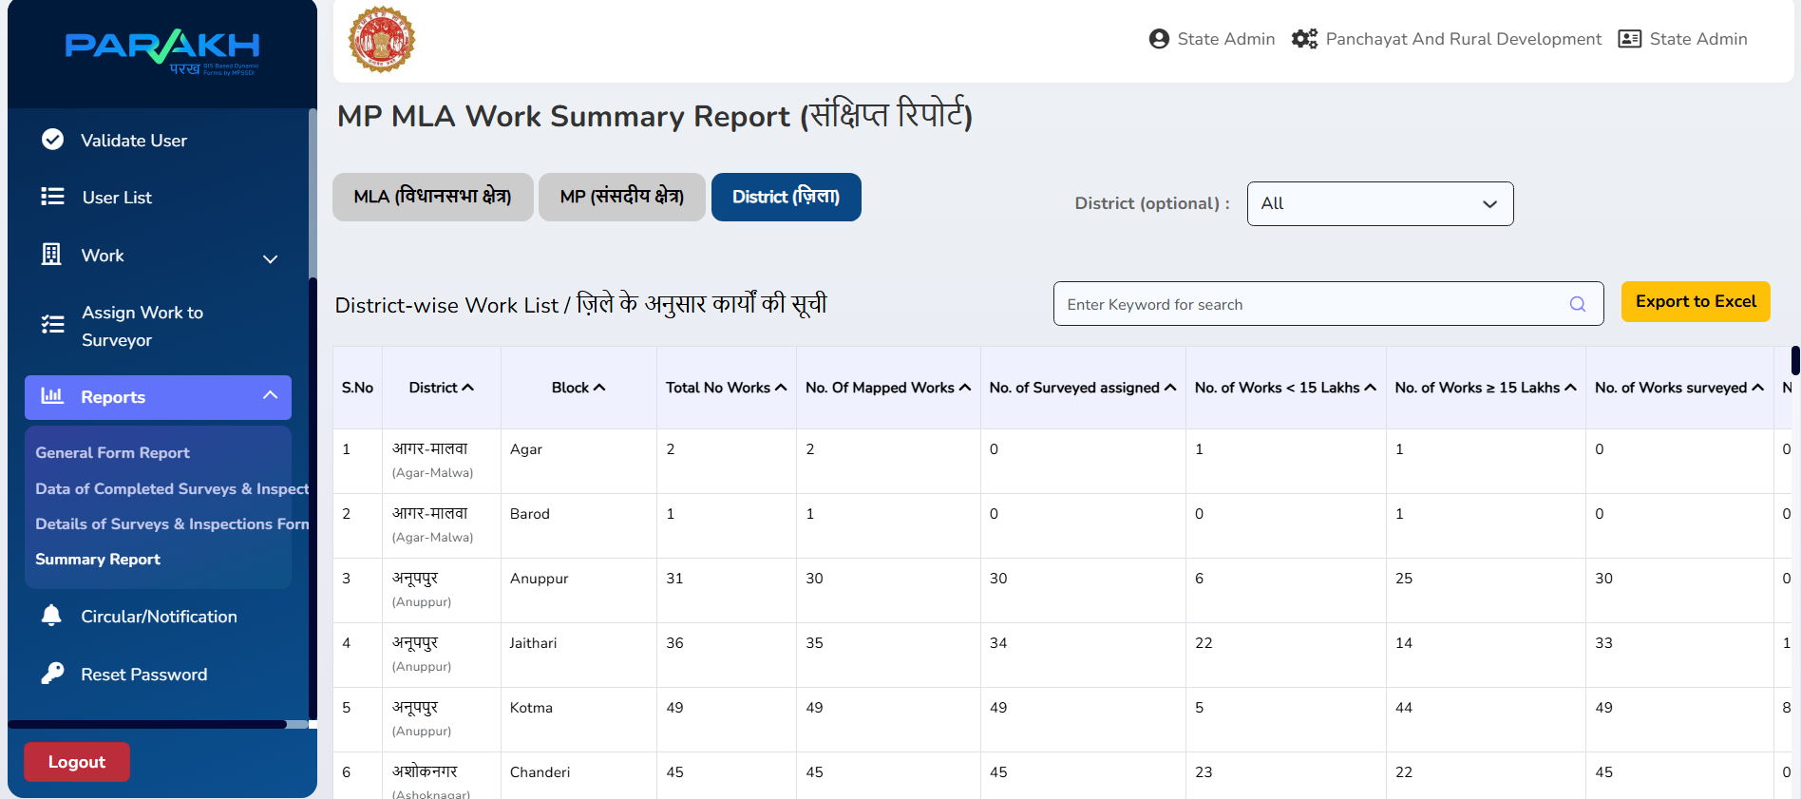
- In View Inspection page – one drop down filter required for all ( MP, MLA, CM Monit A, CM Monit A+, and CM Ghoshna) where for CM pages vidhan sabha lok sabha fields needs to be removed.
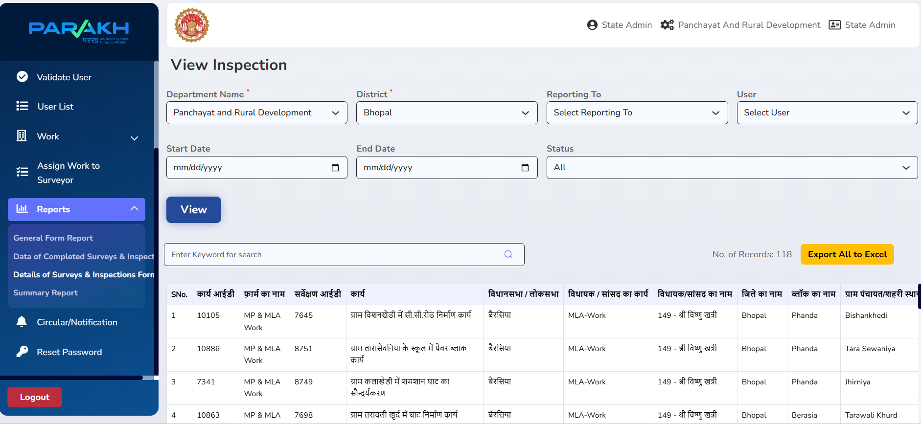

- In MP MLA work Report type of area needed to be updated according to CM Monit related work
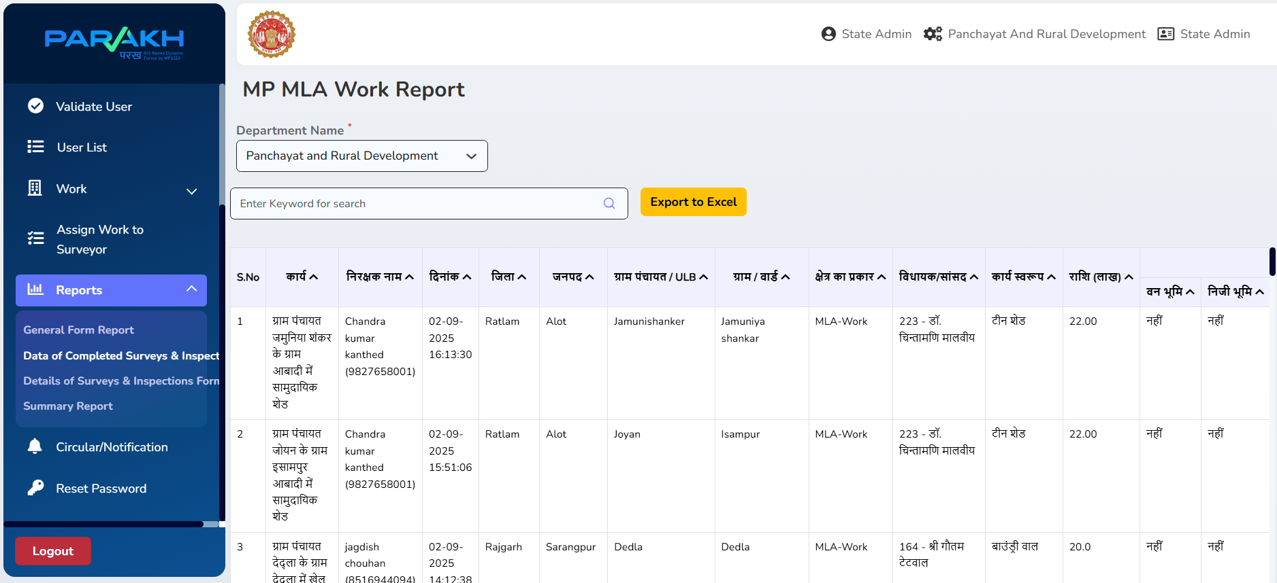
Based on discussion with RES team on meeting date 01.09.2025, please find attachment of cm ghosna work list .
pls add these work under label "CM Ghoshna " in "क्षेत्र का प्रकार"
Please ensure that work should be shown in different dash board for CM A+ Monit /CM A Monit/ CM Ghoshna, and a separate summary report, detailed survey report to be provided for these works.
List of works proposed under CM Monit A+ and CM Monit A will be provided soon.
Now, Prepare a complete BRD Business Requirement specification document and BRTM business requirement traceability matrix according to the CMMI Level 5 guidelines and standards.
Take all above requirement and screenshot data in consideration to generate BRD business requirement document.

